Data Visualization

JointPlot:

A jointplot is used to analyze the relationship between two numerical variables along with their individual distributions.

It has three components:
- Main(center) plot – two variables relationship
- Top marginal plot – X-axis distribution
- Right marginal plot – Y- axis distribution

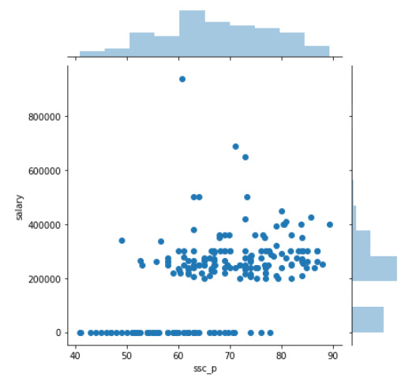
PairPlot:

A pairplot shows pairwise relationships between multiple variables in a dataset

- Understand relationships between variables
- Detect multicollinearity (strong correlations)
- Identify outliers
- Compare distributions
- Powerful tool for quick data exploration

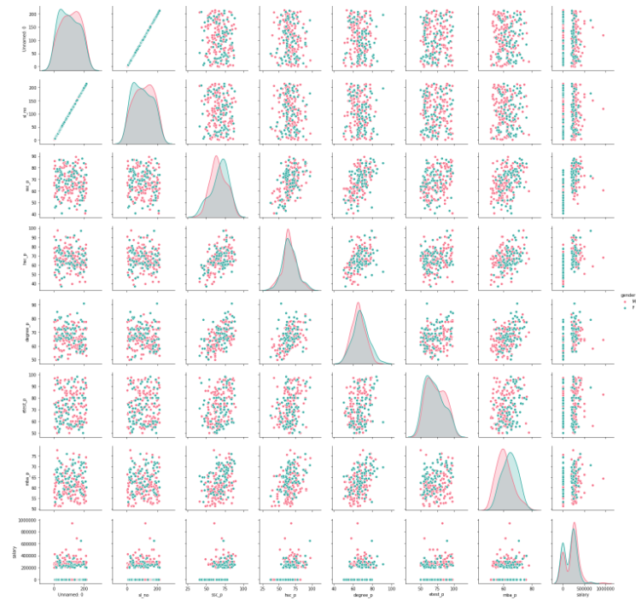

StripPlot:

A stripplot is used to show the distribution of a numerical variable across different categories.

- See all individual data points
- Understand the spread and density of values
- Identify outliers
- Compare distributions across categories

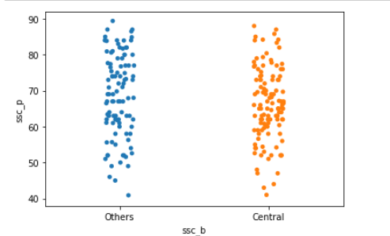

Swarmplot:

A swarmplot is a categorical data visualization that shows the distribution of a numerical variable across categories, while avoiding overlap between points.

- See every individual data point
- Clearly observe the true distribution and density
- Identify clusters and outliers
- Compare categories more accurately

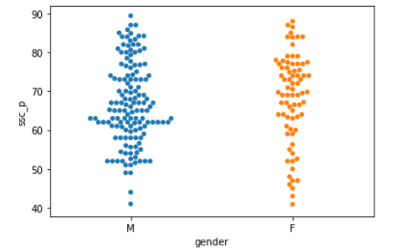

Violinplot:

A violin plot is a statistical visualization used to show the distribution of a numerical variable across categories, combining features of a boxplot and a density plot.

- Shows the full distribution shape
- Compare distributions across categories
- Understand data shape, not just summary values
- Compare variability between groups

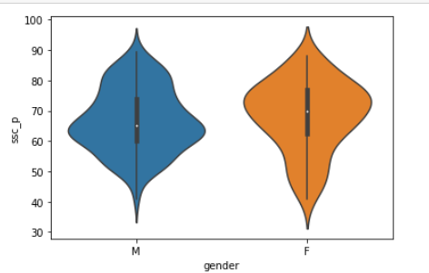

Boxplot:

A boxplot is a graphical way to show the distribution of a numerical variable through its five-number summary and to identify outliers.

Boxplots help you quickly see:
- Central tendency (median)
- Spread (IQR, range)
- Outliers
- Differences between categories

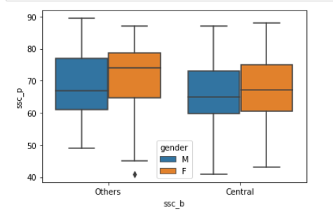

Barplot:

A barplot is a type of chart used to compare quantities across categories. It’s one of the most common ways to visualize categorical data.

- Compare different categories quickly
- Visualize trends or differences
- Show summary statistics like mean, sum, or proportion

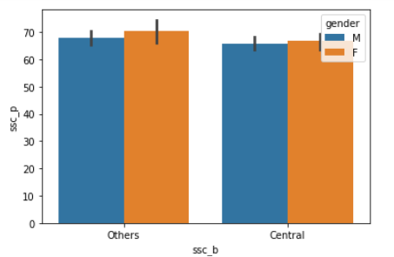

CountPlot:

A countplot is a special type of bar plot that shows the number of occurrences (counts) of each category in a dataset. It’s commonly used with categorical variables.

- Quickly see the frequency of categories
- Identify the most common and least common categories
- Detect imbalances in categorical data
- Visualize categorical distributions before further analysis

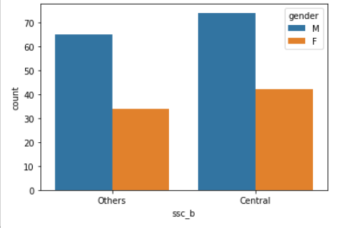

PointPlot:

A point plot is used to show the relationship between a categorical variable and a numerical variable using points and optional connecting lines.

- Compare average values across categories
- Visualize trends over an ordered category
- Include uncertainty through confidence intervals
- Make clean visualizations of summary statistics without plotting all raw data

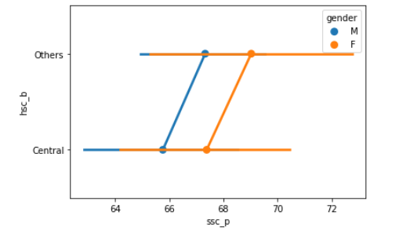

FactorPlot:

A factorplot is used to create categorical plots in a single, flexible function.

- Could create different plot types without changing the function
- multiple plots for different subsets of data
- Simplified exploratory data analysis for categorical data

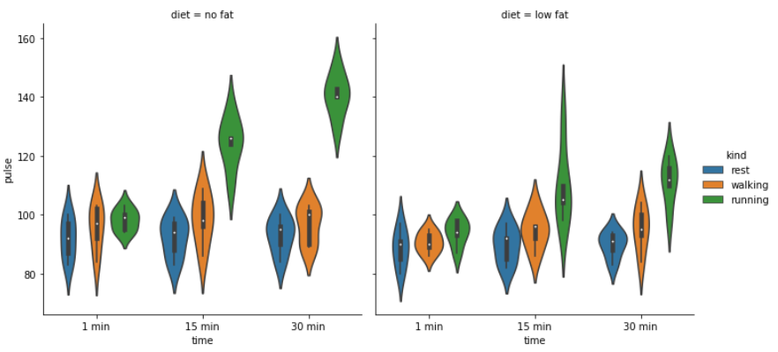

RegPlot:

A regplot is used to visualize the relationship between two numerical variables and optionally fit a regression line to the data. It’s very useful for exploring correlations and trends.

- Visualize correlation between two variables
- See the trend and direction (positive/negative)
- Identify outliers that don’t follow the trend

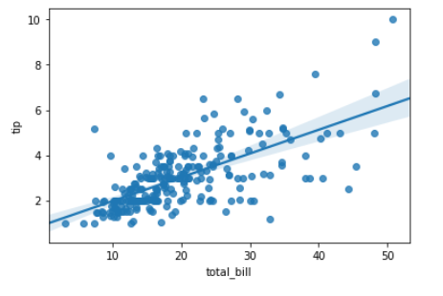
Lmplot:

A lmplot is used to visualize the relationship between two numerical variables with a regression line, and it’s especially powerful when you want to facilitate subgroup comparisons using categorical variables

- Visualize overall trends between numerical variables
- Compare trends across categories
- Detect outliers and clusters

